**Circuit Diagram:**

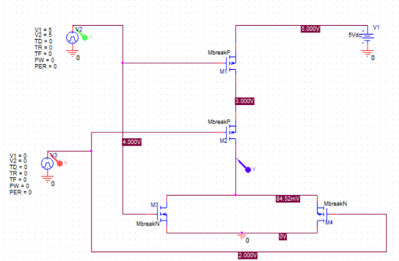

**Simulation Profile:**

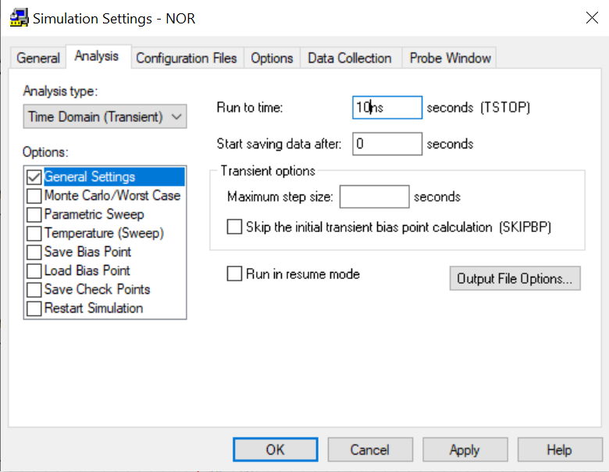

**Output Diagram:**

When input,output is 0V & 5V:

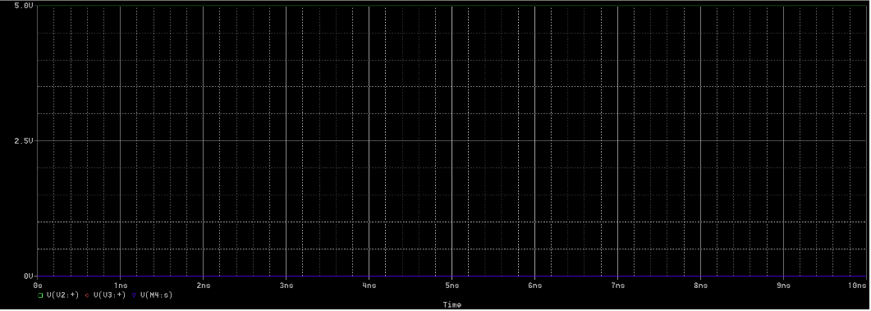

When input,output is 2V & 4V:

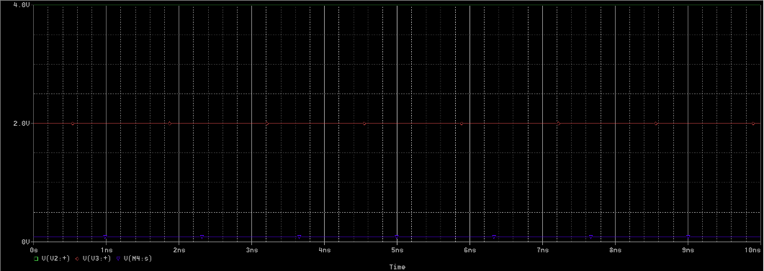

When input,output is 2V & 3V:

